The Sponsors

Barry Callebaut thanked the national and international sponsors of German Chocolate Masters competition for an outstanding performance for a total of over 16,000 €.

National Sponsors

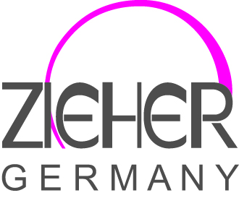
The company Zieher, a leading provider of high-quality porcelain, glassware and buffet systems, supports the competition with high quality and exclusive products from the innovative range.


The AFO & PR Agency is publishing editor of the creative magazine Schokoladenseiten and supports the competition with advertising opportunities.


The Becks Cocoa, a young and innovative company, which makes her mission (is responsible) to combine cocoa with various spices and herbs, provides the participants Tastings from his extravagant and individual cocoa specialties.

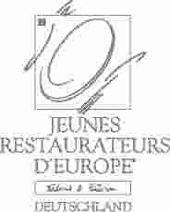
The Jeunes Restaurateurs d'Europe, Germany section, we are grateful for the support of the competition. The winners will receive a coupon for TWENÜ a first-class 3-course meal. That they can redeem at a restorers of the 56 young German associations of top chefs.

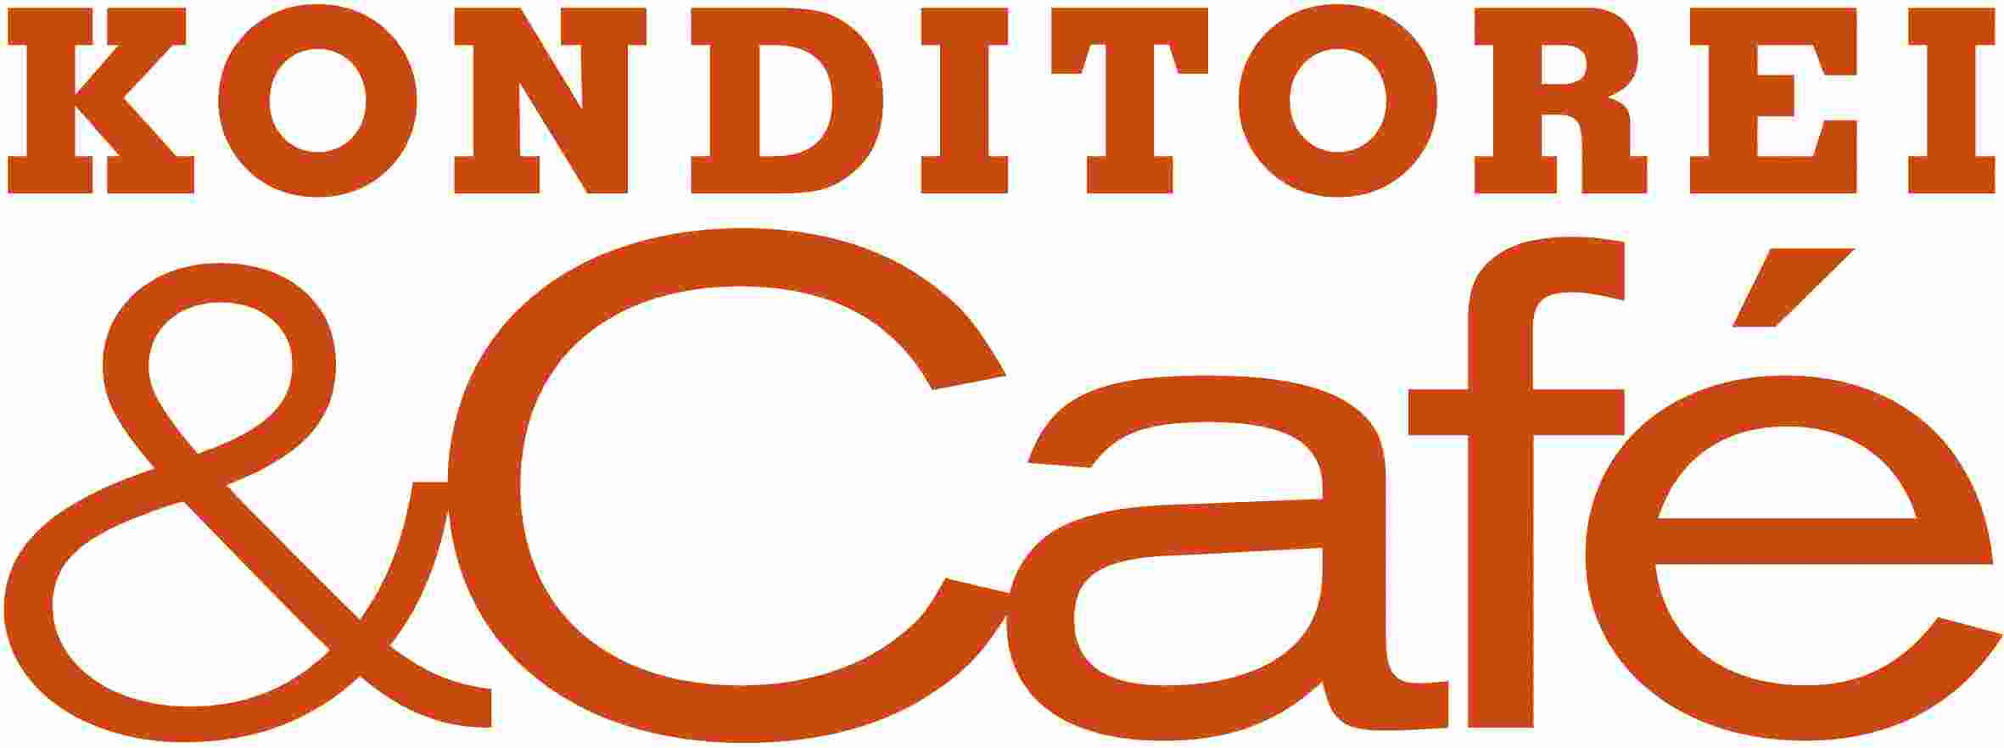
The Matthaes Verlag donates editions of the latest work by world champion Bernd Siefert Pastry: In Sweet Gold 2 are noble and trendy chocolates and chocolate creations - beyond marzipan and ice cream. The leading German Confectionery and Patisserie Konditorei & Café magazine from the Matthaes Verlag is extensively reported about the competition and a look behind the scenes type.

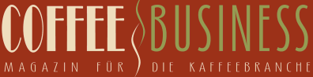
The Coffee-Business Verlagsgesellschaft, which the magazine for the coffee industry, Coffee-Business bring out, we thank for their support in the form of several annual subscribtions the magazine for bakers, confectioners and suppliers.

The Back-Europ GmbH, an association of independent owner and specialized wholesale undertake the nationwide coverage and bakeries, pastry shops, restaurants and ice supply, our thanks for the generous donation.

The demanding customers of Stöver Frische Team of the REWE-bulk service know what is good: Always anew inspire them to the culinary specialties of confectionery Barry Callebaut.

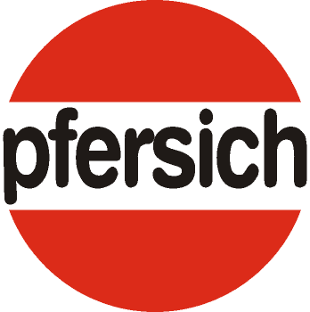
In over 70 years, the import and wholesale trade specialist house Pfersich, Neu-Ulm for specialists for high-quality raw materials and semi-developed kuverture. Pfersich spring for all competition participants voucher goods.

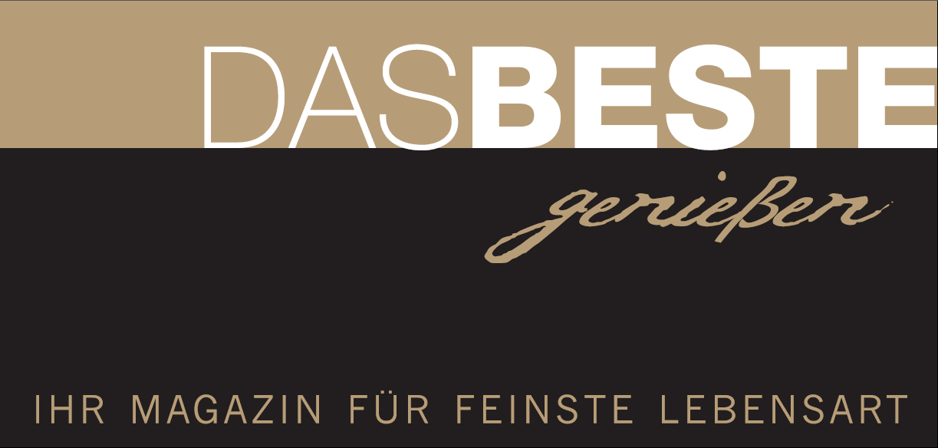
Reni & Franz Schiffner, editor of the magazine “Das Beste genießen” what passionate consumption and enjoy the finest lifestyle, allocates the jury annual subscriptions.

 The company Aichinger GmbH we thank for your gifts in the form of a fine selection of fine spirits.

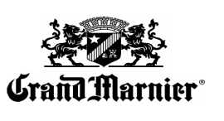
The Campari Deutschland GmbH supports the German Chocolate Masters, with its exclusive anniversary cuvees from Grand Marnier.

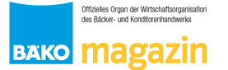
The BÄKO-magazin provides all participants a free yearly available. In addition, reported the BÄKO-magazin detail about the competition and also throws a glance behind the scenes.

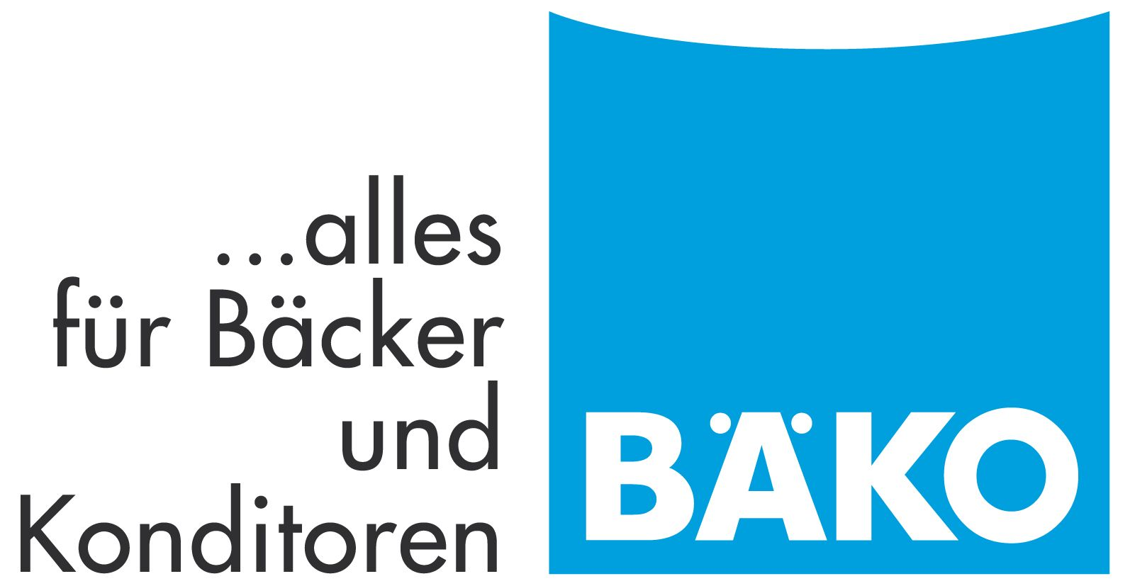
We are grateful for the generous support from Bäko. They dress all candidates and jurors with uniform jackets from cooking. We thank very warmly.

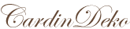 Cardin Deco, a leading provider of specialty equipment in the pastry shop and hotel kitchen donated a fine selection of valuable materials.

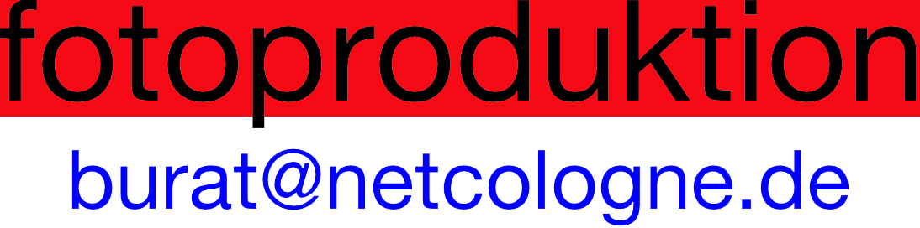
The photo production Wolfgang Burat, our special thanks to professional photography, the competition in impressive manner documented.

International Sponsors
With the stylish lifestyle products from the company Villeroy & Boch, the chocolate works of art presented enjoyable.
The company Kitchen Aid during the competition days throughout their professional equipment available and the winner keeps an attractive gift from her assortment ready.
The competition is thanks to good way to provide quick and coolers Shock freezer from the company Irinox enriched.
The artistic creativity during the competition, participants do not owe the least reliable equipment from the company Prefamac.
Thermohauser specifically dedicated to the second and third placed participants and makes them an attractive gift package together.
For the Mystery Box, some elements of the company Thermohauser and PCB provided, so that participants can handle the challenge.

